**Javascript DOM Assignment**

1. Select an <h2> tag with id of text and change its inner text to “Hello World”.

<html>

    <head>Hello </head>

    <title> Heyy</title>

    <h2 id = "myHeader">Text</h2>

    <button onclick="display()">Change inner text</button>

    <script>

        function display() {

            document.getElementById("myHeader").innerText = "Hello World";

        }

    </script>

</html>

2. Apply following style to the same h2 using Javascript DOM Method.

colour: red,

fontWeight: bold,

textTransform: uppercase

<html>

    <head>Hello </head>

    <title> Heyy</title>

    <h2 id = "myHeader">Text</h2>

    <button onclick="display()">Change inner text</button>

    <script>

        function display() {

            document.getElementById("myHeader").innerText = "Hello World";

            document.getElementById("myHeader").style.color =  "red";

            document.getElementById("myHeader").style.fontWeight =  "bold";

            document.getElementById("myHeader").style.textTransform =  "uppercase";

        }

    </script>

</html>

1. Create a simple calculator that takes the input from input1, input 2 and add them together.

<html>

    <h1>Calculator</h1>

        <script type = "text/javascript">

            function add(){

                var a = document.getElementById("input1").value;

                var b = document.getElementById("input2").value;

                var sum = parseInt(a)+parseInt(b) ;

                document.getElementById("result").value = sum;

            }

        </script>

        <body>

            <input type="text" placeholder= "num1" id="input1"><br>

            <input type="text" placeholder="num2" id = "input2"><br>

            <button onclick="add()" > ADD</button><br>

            <p>Result: <input id = "result"></p>

        </body>

</html>

4. What is the error in the following code?

Ans: Instead of ‘class’ in paragraph tag, need to put ‘id’.

With ‘class’ in p tag => output => Hello World!

With ‘id’ in p tag => output => Hii JS DOM!

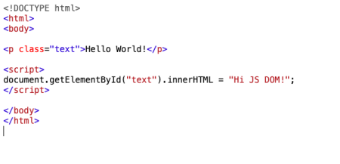5. Using JS Dom select a button and set its onclick event to logging hello in the console.

<!DOCTYPE html>

<html>

<body>

<button id="demo">Click me.</button>

<script>

document.getElementById("demo").addEventListener("click", myFunction);

function myFunction() {

  document.getElementById("demo").innerHTML = "YOU CLICKED ME!";

  console.log("hello")

}

</script>

</body>

</html>

6. Using alert, prevent a person from leaving the screen using JS DOM.

Output -

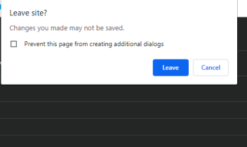

7. Select all the h2 tags on screen and change their colour to purple.

<html>

<h2 >hello</h2>

<h2>welcome</h2>

<h1>hii</h1>

<script>

   const a = document.querySelectorAll("h2");

   for(let i =0; i < a.length; i++ ) {

   a[i].style.color ="purple";

   }

</script>

</html>

8. Create a new <h4> tag on the screen using JS DOM.

document.createElement ("h4")

9. Remove an element from the screen using js dom.

<!DOCTYPE html>

<html>

<body>

<p id="demo">Remove.</p>

<button onclick="remfun()">Remove</button>

<script>

function remfun() {

  const element = document.getElementById("demo");

  element.remove();

}

</script>

</body>

</html>

10. Get the number of <p> tags on the screen using JS DOM.

<html>

    <h2>Hello</h2>

    <p> okk</p>

    <p> Hey</p>

    <p> u there?</p>

    <script type = "text/javascript">

        const pp = document.getElementsByTagName('p').length;

        document.write(pp)

    </script>

</html>

11. Fetch the value of name from the following form.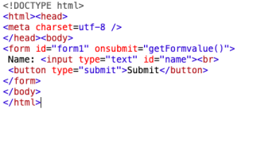

<!DOCTYPE>

<html>

    <head><meta charset="utf-8"/></head>

    <body>

        <form id="form1" onsubmit="getFormValue()">Name: <input type="text" id = "name"><br>

        <button onclick = "fun1()" type="submit">submit</button>

        </form>

        <script type="text/javascript">

            function fun1(){

                let str = document.getElementById("name").value;

                window.alert("name: "+str);

            }

        </script>

        </body>

</html>